Entity Relationship Model Practice Exercises
- A university maintains information about students. Each student has a student ID, name, date of birth, email address, and major. The university stores thousands of student records.
  - Identify the entity
  - Provide three examples of entity instances
  - Identify five attributes of the entity
  - Explain the difference between an entity and an entity instance

- Entity: Student
- Entity instances:
- James
- John
- Sam
- 5 attributes:
- Student_id
- Name
- D.o.b.
- Email
- Major
- Entity is the general subject whereas entity instance is the specific details of data being stored

- A customer database stores the following attributes:
CustomerID
CustomerName
CustomerAddress
DateofBirth
Age
AccountBalance
PhoneNumber
Classify each attribute as one of the following and explain your rationale
  - Atomic or Composite
  - Stored or Derived
A + B)
CustomerID – atomic - derived
CustomerName – atomic – stored
CustomerAddress – composite - stored
DateofBirth – atomic - stored
Age - atomic - stored
AccountBalance – composite - derived
PhoneNumber – atomic - stored

- Analyze the following relationships and identify whether each relationship is One-to-One, One-to-Many, or Many-to-Many.
  - A customer can place many orders: one-to-many
  - A student can enroll in many courses: One-to-Many
  - Each employee has one company parking permit: one-to-one
  - Each department has many employees: many-to-many

- A university bookstore tracks textbooks, authors, publishers, and sales transactions.
  - Identify four possible entities
  - Explain why each item qualifies as an entity
  - Identify one possible instance of each entity
Textbooks
Author
Publisher
Sales

- A medical clinic stores information about patients. Determine whether each item is an entity or an attribute and explain your rationale.
  - Patient – entity: will contain multiple attributes
  - PatientName – attribute: no descriptive sub catagory
  - InsuranceCompany – Entity: attributes could include policy numbers or employee Id
  - Appointment – attribute: no sub catagory
  - PhoneNumber – attribute: it’s a specific data set
  - Physician – Entity: needs more descriptive data

- Analyze the following relationships and identify the relationship type, the parent entity, the child entity, and explain whether an associative entity is required.
  - A person has one passport. A passport belongs to one person.
Relationship is a 1:1 – the person would be the parent entity as a passport cannot exist without a person but a person can exist without a passport

  - A department employs many employees. Each employee works for one department.
Relationship 1:M – parent is the department as it contains multiple employees but each employee may only have one department

  - A student can enroll in many courses. Each course can contain many students.
Relationship M:N – the course is the parent entity

  - A vehicle has one assigned license plate. A license plate belongs to one vehicle.
Relationship 1:1 – the license plate is the parent entity as they are a unique identifier rather than a generic vehicle

- A company stores employee information
EmployeeNumber – Primary Key
SocialInsuranceNumber
EmployeeName
HireDate
  - Select the best primary key
  - Explain why the other attributes are not ideal primary keys
SIN – being a private data instance would be irresponsible to be a primary key
Employee Name – Employees could have the same name making the identifier less effective
Hire Date – Employees could be hired on the same day therefore less effective

- Analyze the following business rules and identify whether each relationship is One-to-One, One-to-Many, or Many-to-Many.
  - Each vehicle has one VIN number. – 1:1
  - A customer can submit multiple support tickets. 1:M
  - A movie can have many actors, and an actor can appear in many movies. - M:N

- A music streaming service stores artists and songs with the following business rules: an artist can create many songs, a song can have many artists, each song must track the artist's contribution.
  - Identify the many-to-many relationship
    - Songs – artists = m:n relationship
  - Create an associative entity to resolve the relationship

  - Identify the primary key of the associative entity

  - Identify all foreign keys

- A restaurant tracks customer reservations, a reservation may use one or more dining tables, and a dining table may be used for many reservations over time. Given the following ERD, answer the corresponding questions:
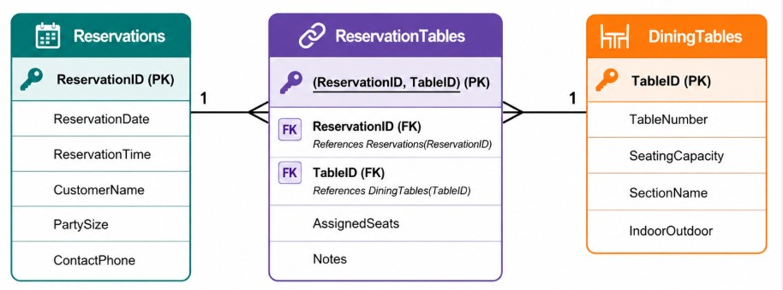
  - Identify the associative entity
  - Explain why ReservationTables requires a composite primary key
  - Identify the relationships
  - Describe the cardinality between Reservations and DiningTables
  - Explain how this design prevents duplicate reservations

